Sent via email

Re. Observation received on use of tarmac on the River bank walk in UL to accommodate the Limerick City Greenway (UL to Annacotty)

Dear Ms. Kennedy,

We wish to inform you that case number 491156 has been opened by Limerick City & County Council (LCCC) to address your concerns regarding the construction methods for the proposed Limerick City Greenway (UL to Annacotty). We note that have not erected any planning site notices along the riverbanks because we have not yet submitted the planning application to An Bord Pleanála.

We would like to provide you with further details about the engineering and environmental assessments that we have undertaken, in coordination with Ryan Hanley Consulting Engineers and other key stakeholders, during the design and consultation stage of this project. We also want to highlight the proposed greenway’s social and inclusive design which will make it fully accessible to all users regardless of their ability especially those with reduced mobility, by providing a paved path with public lighting for its entire length. The proposed design also includes a new wheelchair accessible ramp to Plassey Beach.

The Limerick City Greenway will become a key artery in the Limerick Shannon Metropolitan Area Transport Strategy (LSMATS) cycle network and the National Cycle Network. The proposed greenway will be constructed along an existing paved, gravel, and grass desire line path between the University of Limerick Boat Club and Annacotty Village. The greenway will be a 3.5 to 4.0m wide tarmac path along the southern bank of the Shannon River. It will also include safety and recreational improvements such as new concrete footpaths and off-road tarmac surfaced cycle lanes along University Road and McLoughlin Drive linking to the existing cycle lanes on Plassey Park Rd, new steel bridges at water crossings, public lighting along the total length of the greenway, new rest areas at Plassey Mills and Plassey Beach, new fencing at key locations, and new native Irish trees, plants, and hedgerows will be planted along the proposed greenway.

As part of the process a non-statutory public consultation event took place on the 4th of August where over 100 people visited Kilmurray Village Hall or our Virtual Public Consultation Room https://www.innovision.ie/limerickcitygreenway to view the project and submit any observations and/or concerns regarding the proposed greenway The responses were generally positive, and we have taken into consideration the received observations to further improve the design of the greenway, particularly from an environmental, social, and economic point of view.

The design of the proposed tarmacadam surface is porous, and its gravel sub-base will enable drainage of water off the path. Any rainwater that falls onto the sloped surface will flow towards the river. Between the UL Boat Club and Kilmurray Student Village, the River Shannon flows along the northern bank of the proposed greenway, and the Plassey Mill Race flows on its southern bank. East of Kilmurray Student Village there will be new culverts underneath the proposed path to relieve water from shallow drains on the southern bank of the proposed greenway. There will be new banks at both sides of the proposed greenway and new green strips will be constructed on the banks to stabilize them and to provide a new habitat for native Irish plants to flourish.

The environmental assessment included a range of ecological surveys that were undertaken between Winter 2020 and summer 2022 which were selected during an initial scoping exercise and baseline survey. The ecological surveys that were undertaken included habitats and species of the area such as bats, breeding and wintering birds, lamprey, otters, badgers, and invasive alien plant species. All the surveys were undertaken by a professional team of experienced and qualified ecologists.

Due to the presence of significant mature trees along the riverbank a tree survey was carried out by an experienced and qualified arborist to identify mature (showing in red outline in the drawing below), semi-mature (orange outline) and immature (green outlined) trees to make sure that all mature trees and the majority of semi-mature trees were avoided during the design process. To do this, the designers routed the path around trees and included a tree root protection layer along the riverside greenway to avoid any damage to the tree root system. During the Bird and Bat surveys, our experts identified the location of birds and bats roosts in mature trees so the proposed greenway design avoids the risk of disturbance to these sensitive locations. An example of the design and routing of the greenway to preserve mature and semi-mature trees is provided below. There will be three new trees planted for each immature tree that will be removed during the construction of the proposed greenway.

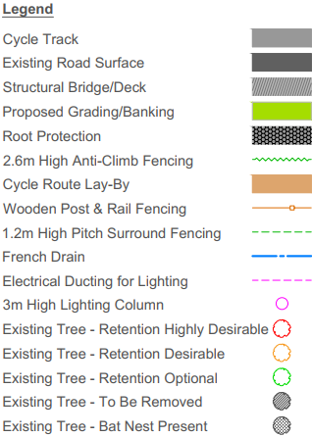
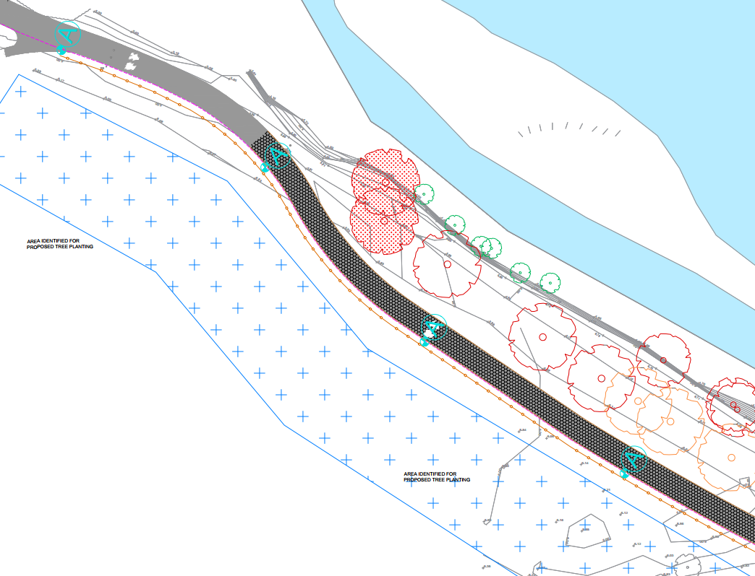

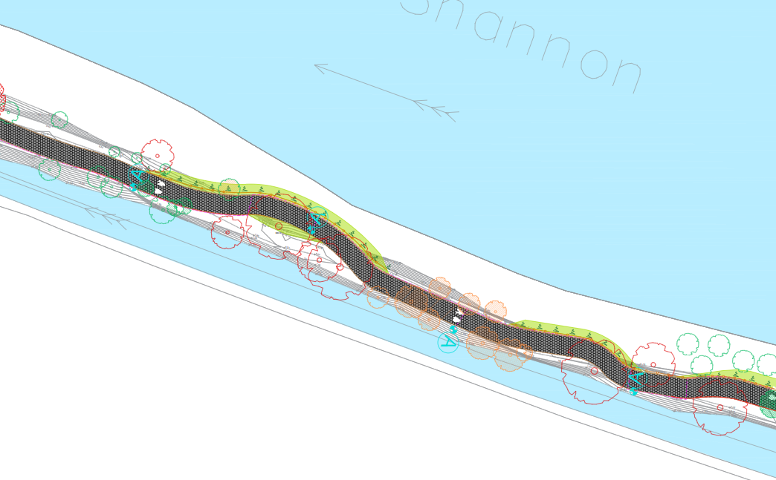

Other Environmental assessments that were undertaken along the proposed greenway route included:
- A water and hydrogeology assessment that concluded the greenway will not create any potential significant effects on the water quality in the River Shannon;
- An archaeology and built heritage assessment,
- A landscape and visual assessment to make sure that these aspects are protected and that the design and construction of the greenway is in harmony with the cultural and traditional aspects of the area; and,
- A flood risk assessment which confirms that the proposed greenway is highly adaptable to increasing flood risk due to climate change. OPW National Flood Hazard Mapping shows that most of the footprint of the proposed greenway is within Flood Zone A and several historical flood events have been recorded in the area. However, on review of the “Planning System and Flood Risk Management” Guidelines of Planning Authorities (2009) a cycle path or path is considered a flood compatible development. The design includes drainage measures to manage water off the greenway surface and culverts will be constructed under the greenway to channel surface water towards the river.

The benefits the proposed Limerick City Greenway (UL to Annacotty) will provide to the local community in east Limerick will include:
- Social: by promoting equality and inclusion through the provision of a safe and even surface for all users, including vulnerable people (with or without their carers), young children, disabled, and sensory impaired. The proposed greenway can also serve as a connection for people to experience local heritage, local ecology, and unique landscapes by providing access to them. They are an opportunity to enhance cultural awareness and community identity, while improving the overall user experience. The proposed greenway will provide a location for groups to meet up, make connections, and train together including weekly Park Runners, the Shannon Dragons (a Breast Cancer Survivors group in Limerick), and teams from the University of Limerick.
- Environmental: by reducing carbon emissions and greenhouse gases. The proposed greenway will improve air quality levels in Limerick and promote sustainable travel modes. They also help reduce potential impacts associated with traffic such as noise levels or pollutants.
- Health: by contributing to the overall health of residents and the community. The proposed greenway will offer people attractive, safe, accessible places to bike, walk, jog, skate, etc., by creating and improving places in the community to be physically active resulting in important health benefits.
- Safety: by being an integral part of the local transportation system and by providing public lighting along the proposed path. The proposed greenway will offer effective and safer transportation alternatives by connecting homes, workplaces, schools, parks, city centres, and cultural attractions along paths that are segregated from vehicular traffic and may contribute to lowering accident rates for cyclists and pedestrians in Limerick.
- Economic: by connecting urban areas to the suburbs of Limerick city, cultural heritage areas, areas of concentrated employment, and by promoting alternative and sustainable forms of tourism and leisure activities. Furthermore, the space and infrastructure required for a large number of pedestrians and cyclists are often significantly more economical when compared to costs associated with new roads or railways that also result in other associated impacts for the environment and human health.

We hope the above information has answered your questions and address your concerns. Our team will remain available to discuss any further details on the design or any other observations regarding the proposed greenway.

We thank you for your observation and participation in the stakeholder consultation stage of the proposed greenway project.

Yours Sincerely,

